Synthetic Film-Damage Restoration Using a Residual ResNet34 U-Net: Quantitative Evaluation and Comparative Review
Bhuwan Rajaa
Vellore Institute of Technology, Chennai, India
Email: [add institutional email before submission]
Abstract. Synthetic scratches, dirt, stains, spots, and hair-like defects can obscure structures in photographs. This paper evaluates a residual ResNet34 U-Net on a source-separated synthetic benchmark using 5,511 buildings and street images. Nine damage families are represented in aligned clean, damaged, and mask records. The final objective combines full-image L1, structural similarity, frozen VGG16 features, and mask-normalized region loss; hair-containing examples are upweighted during continuation training. On 1,654 held-out pairs, mean PSNR improves from 25.0674 to 38.5015 dB, SSIM from 0.908485 to 0.985564, and MAE decreases from 0.024888 to 0.003455. The study contributes a documented defect-generation and source-split protocol, detailed per-defect and mixed-damage analyses, and an explicit distinction between measured results and literature-based comparison candidates. Five modern methods are reviewed but have not been retrained on the project split.
Keywords: Image restoration; synthetic film damage; residual U-Net; PSNR; SSIM; image inpainting; restoration evaluation

1. Introduction
Scratches, dirt, dust, spots, stains, and hair-like marks degrade photographs at spatial scales ranging from isolated pixels to elongated structures and larger patches. The removal problem is not simply classification: the output must reconstruct a plausible RGB image while retaining the content that was not damaged. Paired synthetic data are useful because every corrupted input can be compared with an exact clean target, allowing repeatable evaluation using full-reference metrics.
This study documents and evaluates an implemented residual ResNet34 U-Net restoration system trained on synthetic damage over the buildings and street categories of the Intel Image Classification collection. The central contribution is a reproducible quantitative analysis of the completed experiment, including aggregate and damage-type scores, training diagnostics, qualitative examples, and a literature-grounded comparison with five modern restoration methods. The comparison distinguishes measured evidence from methods that remain candidates for future, controlled experiments.
The study-specific contributions are a source-separated nine-defect benchmark; a residual ResNet34 U-Net with a full-resolution detail branch; a final training objective that combines pixel, structural, feature, and mask-normalized region losses; and an analysis that reports aggregate, per-defect, mixed-damage, and per-pair outcomes. These are contributions in reproducible benchmark construction and training/evaluation practice, not a claim that the underlying encoder-decoder design is a new architecture. Prior work on old-photo restoration highlights both mixed defects and the synthetic-to-real domain gap [6], motivating the deliberately bounded claims made here.

2. Related Work and Comparison Methods
MPRNet (Multi-Stage Progressive Image Restoration) uses a multi-stage process, encoder-decoder context, a high-resolution branch, supervised attention, and cross-stage feature fusion. Its progressive design is relevant where one pass may not recover both broad context and fine structures [1]. A trade-off is greater architectural complexity and the need to validate whether each stage helps this specific synthetic-damage distribution.
SwinIR adapts shifted-window Transformer blocks to image restoration tasks such as denoising and compression-artifact reduction. Windowed attention can model content-dependent relations while remaining more scalable than unrestricted global attention [2]. It is a useful candidate for preserving repetitive facade details and street textures, although its original benchmark tasks are not identical to mask-localized film-defect removal.
Restormer uses efficient attention and feed-forward designs intended to capture long-range pixel interactions for high-resolution restoration. The authors report results across denoising, deraining, and deblurring benchmarks [3]. Its contextual modeling may help infer texture across an occlusion, but inference memory, architecture complexity, and task/domain mismatch should be measured under the same conditions as the current model.
NAFNet derives a compact restoration baseline by simplifying activation functions and block design while retaining strong restoration performance on deblurring and denoising benchmarks [4]. Its simplicity makes it an attractive first neural baseline for a fair ablation study. However, results reported on GoPro or SIDD cannot be transferred numerically to the current synthetic film-damage test set.
LaMa targets image inpainting and large missing regions using fast Fourier convolutions, a large receptive field, and a high-receptive-field perceptual loss [5]. Its mask-oriented formulation is especially relevant to stains and larger damaged patches. The current restoration model receives only the damaged RGB image at inference, whereas a LaMa implementation commonly uses a mask; the comparison protocol must therefore state whether the known synthetic mask is supplied or predicted.
These methods represent complementary directions rather than a leaderboard that can be read directly from published numbers. Each source uses different datasets, degradation models, image resolutions, training splits, and metric implementations. We consequently compare their mechanisms and suitability here, and reserve a numeric cross-model ranking for future retraining on the same fixed split.
Closely related work provides useful design contrasts. Wan et al. address mixed degradation in old photographs and identify the gap between synthetic pairs and real damaged images [6]. Partial convolutions and LaMa make use of explicit masks or image-wide context to complete irregular or large missing regions [5], [7], whereas the present model receives only RGB at inference. Deep Image Prior illustrates an image-specific, unpaired restoration alternative [8]. Residual learning and U-Net skip connections are established architectural components [11], [12], not innovations claimed by this study. SSIM and pretrained-feature perceptual losses motivate the structural and VGG terms in the objective [9], [10]. Real-ESRGAN also demonstrates the value of synthetic degradation modeling, although its super-resolution task and benchmark are distinct [13].
Recent restoration literature further broadens the design space. Uformer combines a hierarchical U-shaped encoder–decoder with locally enhanced window attention [14]. PromptIR uses learned prompts to condition one restoration network on several degradation types and levels [15], while DiffIR estimates a compact restoration prior and uses a diffusion-based process to guide reconstruction [16]. DnCNN remains a useful residual-learning reference for denoising and related inverse problems [17]. These methods suggest distinct hypotheses for this project: multi-stage refinement may improve mixed defects, windowed or efficient attention may preserve repeated building and street structure, prompt conditioning may handle multiple defect families, and diffusion priors may improve plausibility when evidence is missing. They are not evaluated on the present test split, so their published metrics are not treated as comparable experimental results. HINet explores half-instance normalization in a multi-stage CNN [18], while FFDNet conditions denoising on a tunable noise-level map [19]. The Smartphone Image Denoising Dataset (SIDD) also illustrates the value of real-capture degradation benchmarks [20]. Its noise model is different from synthetic film defects, but it reinforces that the present experiment is a controlled starting point rather than proof of generalization to naturally aged photographs.

3. Dataset and Experimental Protocol
The source collection contains 5,511 photographs: 2,628 buildings images and 2,883 street images. A stratified 70/15/15 split with seed 42 was made before corruptions were generated. Training contains 3,857 distinct source images and 7,714 pairs; validation contains 827 source images and 1,654 pairs; the test partition contains 827 source images and 1,654 pairs. All variants of a source remain within one split. This reduces direct source-identity leakage across train, validation, and test partitions.
Images are converted to RGB and resized to 256 x 256. Each source yields two deterministic variants using a seed derived from the global seed, source ID, and variant index. Nine configured damage families are represented: dirt, dots, scratches, smut, spots, sprinkles, stain, long hair, and short hair. The active test set contains light and medium severities; heavy damage was not included in the final benchmark. Transparent PNG artifact masks are rotated and rescaled, placed with a Perlin-noise-guided spatial probability field, and combined to mark the intended defect support. The synthetic mask is used for training supervision and evaluation grouping, but is not provided to the network at inference.
The paired dataset provides exact targets for repeatable evaluation of the synthetic defect family, but does not establish performance on naturally aged photographs.
The data pipeline keeps transparent artifact shapes, clean/damaged images, and binary masks aligned; deterministic seeds make a given source/variant repeatable under the recorded software and asset versions.

4. Restoration Network and Training Objective
The model uses a ResNet34 encoder, a multi-scale decoder, skip connections, and a full-resolution detail branch. The classification head is removed. Decoder features are resized and concatenated with encoder features, ending in a three-channel correction convolution. The output is residual: the predicted correction is added to the damaged input. The correction layer is zero-initialized, so an untrained model begins as an identity mapping. The network receives only the RGB damaged image, normalized internally for the encoder; the full-resolution branch also sees the [0,1] image.
The final continuation trains with a weighted objective that combines full-image L1 loss, a Gaussian-window structural term, a frozen VGG16 feature loss, and a damage-region-normalized L1 term. The objective is L = L_pixel + 0.2 L_structural + 0.02 L_VGG + 0.1 L_region. The region term gives a small hair mask influence proportional to its own support rather than allowing it to vanish in the full-image average. Hair-containing training pairs are sampled with weight 2 relative to other examples; the identity-example probability is 0.05. Training uses AdamW, batch size four, mixed precision, and gradient clipping.
The parent v2 checkpoint completed 35 epochs. The final continuation trained for another 85 epochs, with the selected checkpoint at global epoch 119 (continuation epoch 84) chosen by the final validation objective. Both models are evaluated on the same saved test split. The dataset contains two variants per source, so pair counts are not independent source counts.
The mask-normalized region term is the study-specific training adjustment. It increases the relative influence of sparse hair and scratch regions that may contribute little to whole-image loss. Hair-containing records are sampled with weight 2.0 in the final continuation. The continuation also lowers identity-example probability and trains from the parent checkpoint for 85 additional epochs; these changes are jointly evaluated and should not be interpreted as an isolated ablation of the region loss.

5. Evaluation Metrics
For normalized RGB prediction P and clean target I, let e = P - I. Mean absolute error is MAE = mean(|e|), and mean squared error is MSE = mean(e^2). Peak signal-to-noise ratio is PSNR = 10 log10(1/MSE) dB when the image range is normalized to one. Structural similarity (SSIM) compares luminance, contrast, and structure using the evaluation implementation. Higher PSNR and SSIM and lower MAE and MSE indicate better full-reference fidelity. The final saved test report uses scikit-image SSIM with data_range=1 and channel_axis=-1; the training plots use the project’s Gaussian-window SSIM, so the two SSIM values are not exactly interchangeable.
All reported test values are means over individual test pairs. PSNR is averaged after calculating it for each pair; because the logarithm is nonlinear, it is not equal in general to PSNR calculated from mean MSE. Full-image measures can also understate error in tiny damaged regions because most pixels may be unchanged. We therefore include damage-family groups and validation-region diagnostics alongside aggregate results.

6. Quantitative Results
Table 1 and Fig. 1 summarize the damaged inputs, the parent v2 checkpoint, and the final exported model on 1,654 identical test pairs. Relative to damaged input, the final model gains 13.4341 dB mean PSNR, increases SSIM by 0.077079, and lowers MAE by approximately 86.12% and MSE by approximately 95.33%. Relative to parent v2, mean PSNR rises by 4.1134 dB and SSIM rises by 0.011698. The final model is validation-selected at epoch 119; the results do not imply that every individual image improves.
By source category, the final model reaches 38.5382 dB PSNR and 0.984849 SSIM over 790 buildings pairs, and 38.4680 dB PSNR and 0.986217 SSIM over 864 street pairs. By severity, the 824 light-damage pairs reach 40.2836 dB, compared with 36.7323 dB for 830 medium-damage pairs. Medium defects remain harder after restoration despite a larger gain from their lower initial quality.
All nine single-damage groups improve over both the damaged input and parent v2. Final PSNR is highest for spots (52.3887 dB) and dirt (51.1904 dB), where defects may occupy few pixels; dots (33.0051 dB) and stain (35.5428 dB) remain the lowest-scoring categories. The means need to be interpreted alongside sparsity: a tiny defect in a large mostly-correct image can produce high full-image PSNR even if some defect pixels remain.
For 827 mixed-damage pairs, PSNR rises from 21.2202 to 34.4750 dB and SSIM from 0.872947 to 0.978116. Across all pairs, PSNR improves for 1,640/1,654 (99.15%) and SSIM for 1,648/1,654 (99.64%); 14 pairs worsen in PSNR and six worsen in SSIM.
TABLE I. OVERALL HELD-OUT TEST RESULTS (1,654 PAIRS)
Measure | Damaged | Previous v2 | Final
PSNR (dB) | 25.0674 | 34.3881 | 38.5015
SSIM | 0.908485 | 0.973866 | 0.985564
MAE | 0.0248880 | 0.00508835 | 0.00345525
MSE | 0.0125223 | 0.00103585 | 0.00058516
Pairs | 1,654 | 1,654 | 1,654

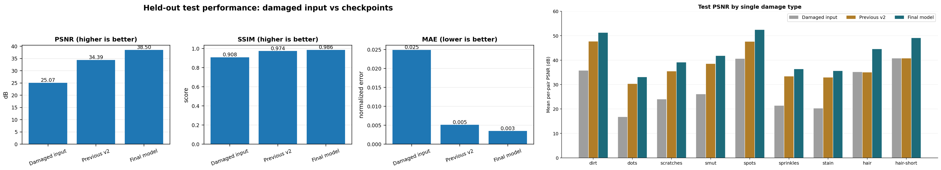
Fig. 1. Held-out restoration metrics and per-damage-type PSNR for the damaged input, previous checkpoint, and final model.
TABLE II. PSNR BY SINGLE DAMAGE TYPE (DB)
Damage | Input | Previous v2 | Final
Dirt | 35.6881 | 47.6557 | 51.1904
Dots | 16.7437 | 30.3006 | 33.0051
Scratches | 23.9120 | 35.4041 | 39.0519
Smut | 25.9985 | 38.4859 | 41.7553
Spots | 40.5623 | 47.5734 | 52.3887
Sprinkles | 21.3587 | 33.3613 | 36.2980
Stain | 20.2417 | 32.9221 | 35.5428
Long hair | 35.1101 | 34.9399 | 44.5339
Short hair | 40.7449 | 40.6726 | 49.0564

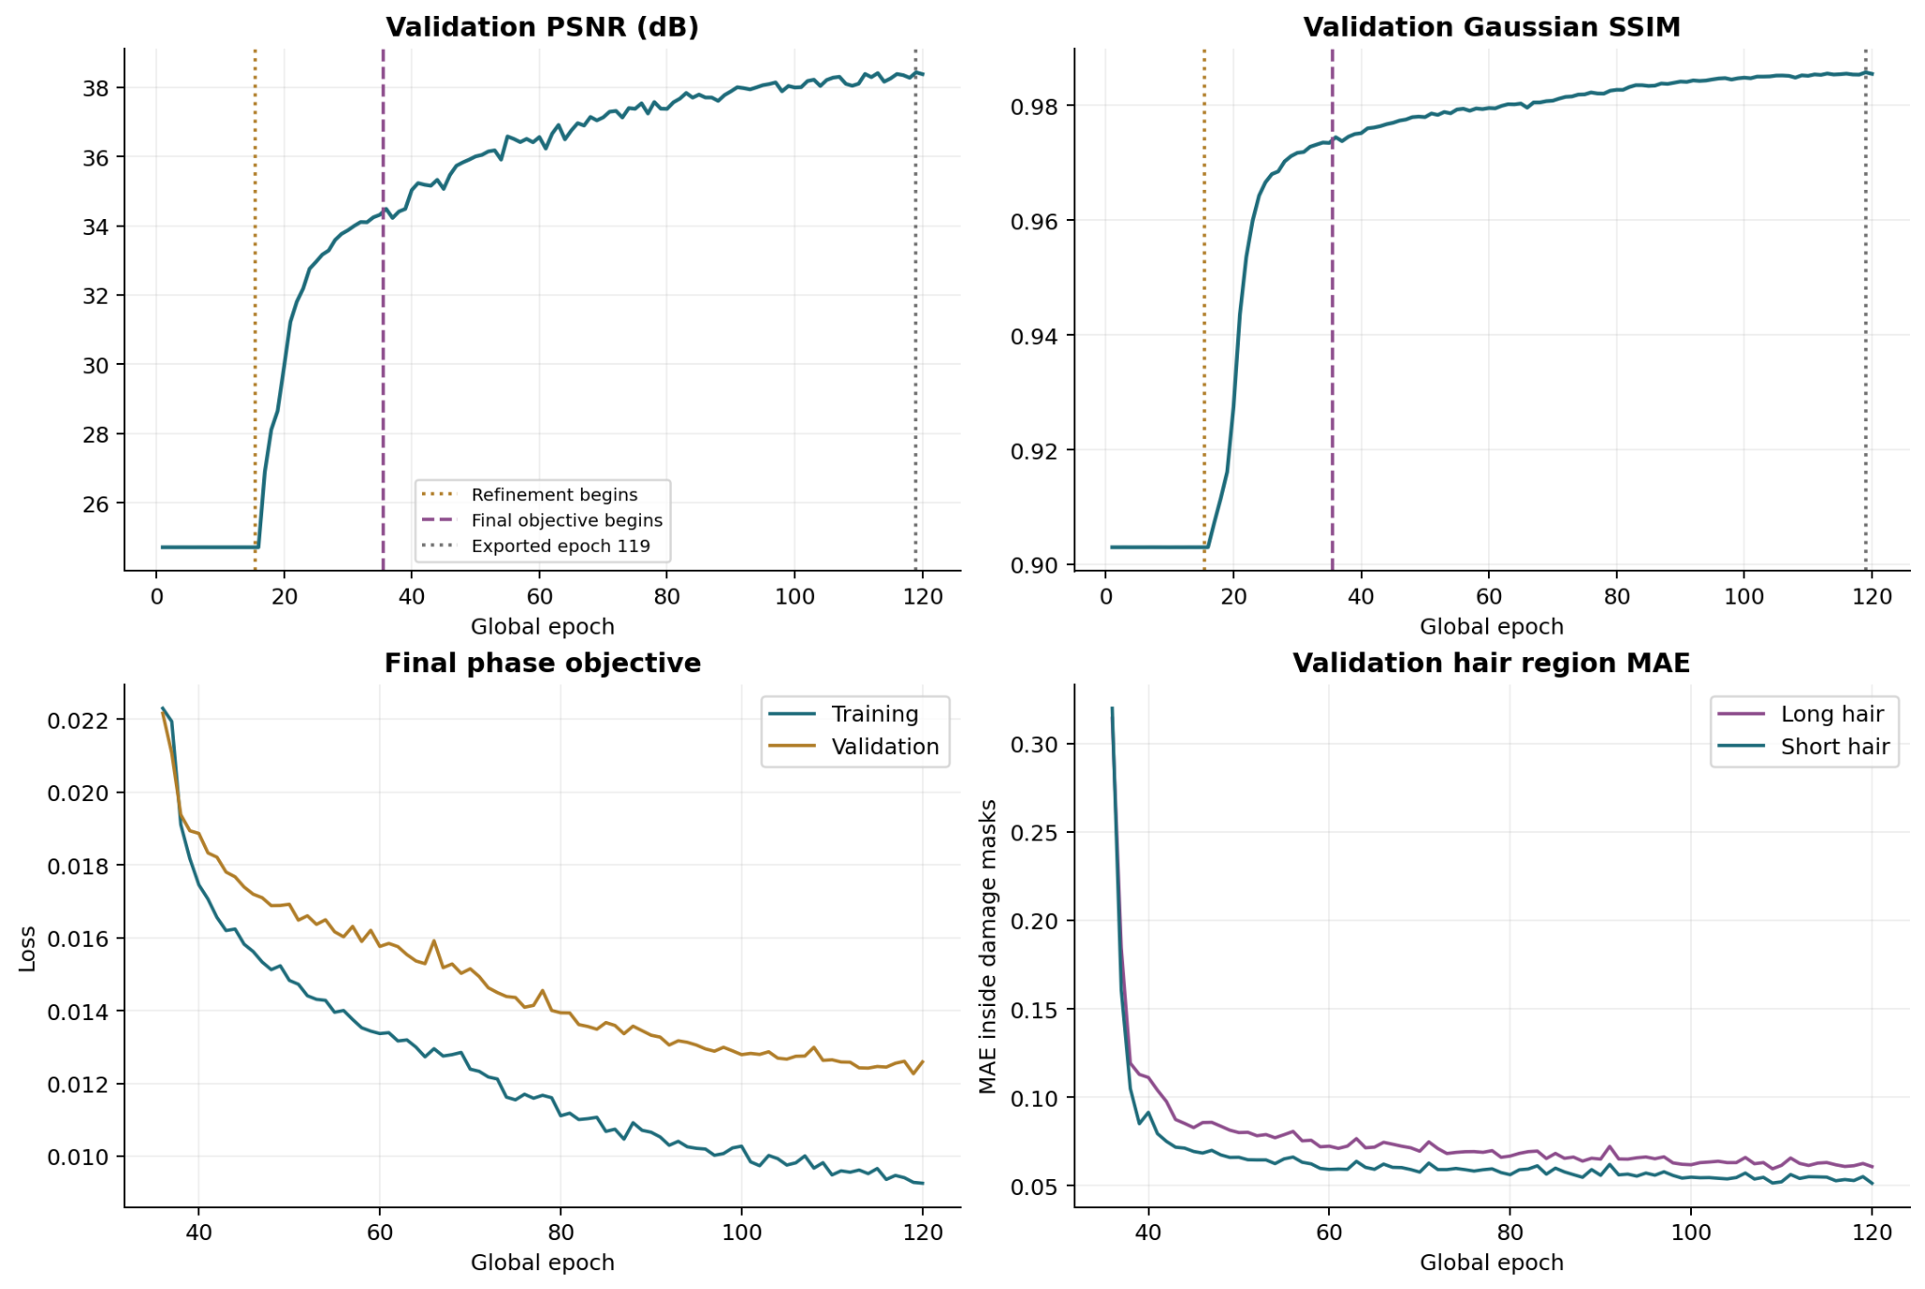
Fig. 2. Validation metrics, final objective, and hair-region validation diagnostics across training.
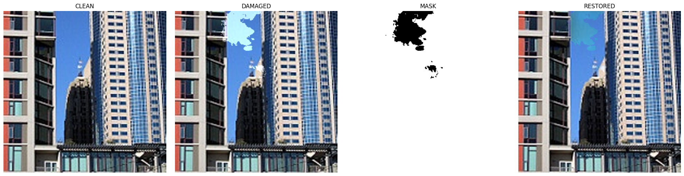
Fig. 3. Buildings example: clean target, damaged input, binary damage mask, and restored output.

7. Comparison with Five Modern Restoration Methods
Table 3 summarizes expected strengths and limitations relative to the current residual U-Net. The current model has measured results on the project split; the five literature methods have not been reimplemented or tested against the provided test records. Published metric values are intentionally not mixed into Table 1 because their benchmarks and degradation protocols differ.
MPRNet is a promising candidate for mixed defects because progressive stages can separate coarse contextual recovery from detail refinement. Restormer and SwinIR provide alternative long-range modeling mechanisms that may help connect lines, building windows, road markings, and textured surfaces around missing patches. NAFNet is a lower-complexity candidate that helps test whether the current multibranch architecture is necessary. LaMa is the most directly mask-oriented candidate for large stains and occlusions; however, using a ground-truth mask at test time would give it extra information unless comparable predicted masks were supplied to every method.
A rigorous numerical comparison should train or fine-tune all methods on the same 7,714 training pairs, use the same 1,654 held-out test pairs, standardize image ranges and SSIM implementation, tune only on validation data, and report average runtime, parameter count, memory, PSNR, SSIM, MAE, and damage-region error. Source-level bootstrapping should resample the 827 test source images as groups, preserving the two variants per source. A separate robustness test should use real damage rather than only synthetic overlays.
The five literature methods are therefore candidate baselines, not numerical results for this benchmark. A fair comparison must use identical source partitions, RGB preprocessing, output clamping, metric implementations, and validation-only model selection; any known-mask inpainting method must be given matching mask information or evaluated in a separate setting.
TABLE III. ARCHITECTURE-LEVEL COMPARISON
Method | Core design | Study-specific interpretation
Current residual ResNet34 U-Net | ResNet34 encoder, U-Net skips, detail branch, residual RGB correction, region-normalized loss | Measured on this split; no explicit mask at inference
MPRNet [1] | Progressive multi-stage restoration, high-resolution branch, supervised attention, cross-stage feature fusion | Strong candidate for mixed defects and detail refinement; more stages and compute to evaluate
SwinIR [2] | Shifted-window Transformer blocks for content-adaptive feature modeling | Candidate for repetitive texture and long-range context; evaluate memory/runtime and defect-specific fit
Restormer [3] | Efficient attention and feed-forward blocks for high-resolution restoration | Candidate for contextual reconstruction across occlusions; more architectural complexity
NAFNet [4] | Simplified activation-free restoration blocks | Useful efficient neural baseline; verify performance on structured synthetic defects
LaMa [5] | Fourier convolutions and image-wide receptive field for mask-based inpainting | Closest mask-oriented candidate for larger stains; mask availability must be matched fairly

8. Classification Metrics and Confusion Matrix
Accuracy, precision, recall, F1-score, classification error rate, and a confusion matrix are not defined by the present experiment as recorded. The network produces three-channel continuous RGB images, not categorical predictions. A confusion matrix requires discrete ground-truth labels and discrete predicted classes, while the stored benchmark provides paired image-level PSNR, SSIM, MAE, and MSE. Assigning classification scores without an explicit decision rule would be misleading.
A separate pixel-level localization task could define positives using the known synthetic mask and a pre-registered rule for the predicted correction support. That would measure localization of changes, not correctness of the reconstructed RGB values; restoration correctness still requires comparison with the clean target under an explicit error tolerance. The saved report does not contain full-test pixel counts under such a rule, so confusion-matrix values cannot be derived from the available evidence.
The available pair-level outcome rates are 99.15% improved in PSNR and 99.64% improved in SSIM. These are improvement proportions, not classification accuracy. The paper reports MAE/MSE and full-reference PSNR/SSIM directly; accuracy, precision, recall, F1, classification error rate, and a confusion matrix remain not applicable without the defined pixel-label task.
TABLE IV. STATUS OF REQUESTED CLASSIFICATION METRICS
Requested measure | Status | Reason / available substitute
Accuracy | N/A | RGB regression; no predicted class labels
Precision | N/A | Needs binary/ multiclass predictions and labels
Recall | N/A | Needs a defined positive class
F1-score | N/A | Depends on precision and recall
Classification error rate | N/A | Not the same as MAE or MSE
Confusion matrix | N/A | No discrete class predictions saved
Continuous restoration errors | Reported | MAE = 0.00345525; MSE = 0.00058516

9. Limitations and Future Work
The benchmark uses synthetic light and medium damage on buildings and street photographs. Real ageing, fading, compression, and overlapping defects may differ from the simulator; the source images were resized from approximately 150 × 150 to 256 × 256, which adds no scene detail. Near-duplicate photographs were not audited, and no human preference study, repeated-seed analysis, or confidence intervals were recorded. Fourteen pairs worsened in PSNR and six in SSIM, so average scores do not eliminate the need for per-image safeguards.
Future work should evaluate real damaged scans, export test-time damage-region and clean-region errors, run at least three seeds, and compare the five candidates under a shared training and inference budget. Thresholds for pixel-level localization should be fixed on validation data before the test set is evaluated. Source-grouped bootstrap sampling is preferable because each original photograph contributes two correlated variants.

10. Conclusion
The final residual ResNet34 U-Net substantially improves full-reference fidelity on the saved held-out synthetic benchmark: mean PSNR is 38.5015 dB, SSIM is 0.985564, and MAE is 0.003455 over 1,654 pairs. The paper’s contribution lies in the documented multi-defect benchmark protocol, region-sensitive continuation objective, and granular evaluation rather than a claim that the architecture is new or superior to untested alternatives.

References
[1] S. W. Zamir, A. Arora, S. Khan, M. Hayat, F. S. Khan, M.-H. Yang, and L. Shao, “Multi-Stage Progressive Image Restoration,” in Proc. IEEE/CVF Conference on Computer Vision and Pattern Recognition (CVPR), 2021, pp. 14821–14831, doi: 10.1109/CVPR46437.2021.01458.
[2] J. Liang, J. Cao, G. Sun, K. Zhang, L. Van Gool, and R. Timofte, “SwinIR: Image Restoration Using Swin Transformer,” in Proc. IEEE/CVF International Conference on Computer Vision Workshops (ICCVW), 2021, pp. 1833–1844, doi: 10.1109/ICCVW54120.2021.00210.
[3] S. W. Zamir, A. Arora, S. Khan, M. Hayat, F. S. Khan, and M.-H. Yang, “Restormer: Efficient Transformer for High-Resolution Image Restoration,” in Proc. IEEE/CVF Conference on Computer Vision and Pattern Recognition (CVPR), 2022, pp. 5728–5739, doi: 10.1109/CVPR52688.2022.00564.
[4] L. Chen, X. Chu, X. Zhang, and J. Sun, “Simple Baselines for Image Restoration,” in Proc. European Conference on Computer Vision (ECCV), 2022, Lecture Notes in Computer Science, vol. 13697, pp. 17–33, doi: 10.1007/978-3-031-20071-7_2.
[5] R. Suvorov, E. Logacheva, A. Mashikhin, A. Remizova, A. Ashukha, A. Silvestrov, N. Kong, H. Goka, K. Park, and V. Lempitsky, “Resolution-Robust Large Mask Inpainting with Fourier Convolutions,” in Proc. IEEE/CVF Winter Conference on Applications of Computer Vision (WACV), 2022, pp. 2149–2159.
[6] Z. Wan, B. Zhang, D. Chen, P. Zhang, D. Chen, J. Liao, and F. Wen, “Bringing Old Photos Back to Life,” in Proc. IEEE/CVF Conference on Computer Vision and Pattern Recognition (CVPR), 2020, pp. 2747–2757.
[7] G. Liu, F. A. Reda, K. J. Shih, T.-C. Wang, A. Tao, and B. Catanzaro, “Image Inpainting for Irregular Holes Using Partial Convolutions,” in Proc. European Conference on Computer Vision (ECCV), 2018, pp. 85–100.
[8] D. Ulyanov, A. Vedaldi, and V. Lempitsky, “Deep Image Prior,” in Proc. IEEE/CVF Conference on Computer Vision and Pattern Recognition (CVPR), 2018, pp. 9446–9454.
[9] Z. Wang, A. C. Bovik, H. R. Sheikh, and E. P. Simoncelli, “Image Quality Assessment: From Error Visibility to Structural Similarity,” IEEE Transactions on Image Processing, vol. 13, no. 4, pp. 600–612, 2004, doi: 10.1109/TIP.2003.819861.
[10] J. Johnson, A. Alahi, and L. Fei-Fei, “Perceptual Losses for Real-Time Style Transfer and Super-Resolution,” in Proc. European Conference on Computer Vision (ECCV), 2016, pp. 694–711.
[11] K. He, X. Zhang, S. Ren, and J. Sun, “Deep Residual Learning for Image Recognition,” in Proc. IEEE Conference on Computer Vision and Pattern Recognition (CVPR), 2016, pp. 770–778.
[12] O. Ronneberger, P. Fischer, and T. Brox, “U-Net: Convolutional Networks for Biomedical Image Segmentation,” in Medical Image Computing and Computer-Assisted Intervention (MICCAI), 2015, pp. 234–241.
[13] X. Wang, L. Xie, C. Dong, and Y. Shan, “Real-ESRGAN: Training Real-World Blind Super-Resolution with Pure Synthetic Data,” in Proc. IEEE/CVF International Conference on Computer Vision Workshops (ICCVW), 2021, pp. 1905–1914, doi: 10.1109/ICCVW54120.2021.00217.
[14] Z. Wang, X. Cun, J. Bao, W. Zhou, J. Liu, and H. Li, “Uformer: A General U-Shaped Transformer for Image Restoration,” in Proc. IEEE/CVF Conference on Computer Vision and Pattern Recognition (CVPR), 2022, pp. 17683–17693, doi: 10.1109/CVPR52688.2022.01716.
[15] V. Potlapalli, S. W. Zamir, S. Khan, and F. S. Khan, “PromptIR: Prompting for All-in-One Image Restoration,” in Advances in Neural Information Processing Systems, vol. 36, 2023, doi: 10.52202/075280-3121.
[16] B. Xia, Y. Zhang, S. Wang, Y. Wang, X. Wu, Y. Tian, W. Yang, and L. Van Gool, “DiffIR: Efficient Diffusion Model for Image Restoration,” in Proc. IEEE/CVF International Conference on Computer Vision (ICCV), 2023, pp. 13095–13105.
[17] K. Zhang, W. Zuo, Y. Chen, D. Meng, and L. Zhang, “Beyond a Gaussian Denoiser: Residual Learning of Deep CNN for Image Denoising,” IEEE Transactions on Image Processing, vol. 26, no. 7, pp. 3142–3155, Jul. 2017, doi: 10.1109/TIP.2017.2662206.
[18] L. Chen, X. Lu, J. Zhang, X. Chu, and C. Chen, “HINet: Half Instance Normalization Network for Image Restoration,” in Proc. IEEE/CVF Conference on Computer Vision and Pattern Recognition (CVPR) Workshops, 2021, pp. 182–192, doi: 10.1109/CVPRW53098.2021.00027.
[19] K. Zhang, W. Zuo, and L. Zhang, “FFDNet: Toward a Fast and Flexible Solution for CNN-Based Image Denoising,” IEEE Transactions on Image Processing, vol. 27, no. 9, pp. 4608–4622, Sep. 2018, doi: 10.1109/TIP.2018.2839891.
[20] A. Abdelhamed, S. Lin, and M. S. Brown, “A High-Quality Denoising Dataset for Smartphone Cameras,” in Proc. IEEE/CVF Conference on Computer Vision and Pattern Recognition (CVPR), 2018, pp. 1692–1700, doi: 10.1109/CVPR.2018.00182.

